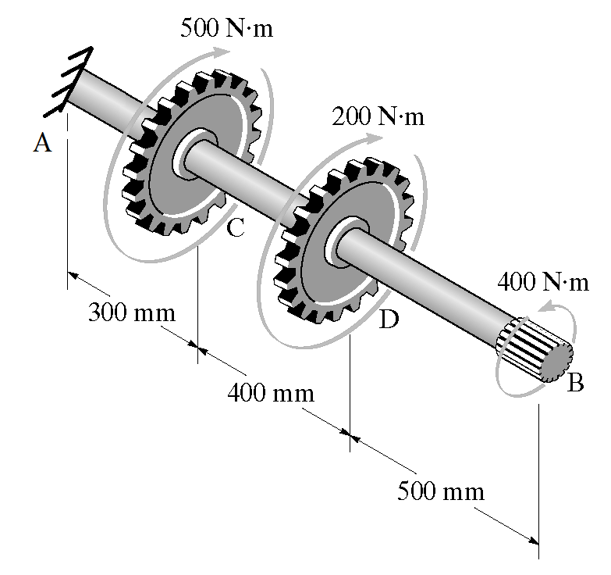
- The gears attached to the steel shaft and the splined end at B are subjected to the torques shown. The shaft is fixed at A. Assume that the shear modulus of elasticity is 80 GPa and the shaft has a diameter of 12 mm. Determine the maximum shear stress in the shaft. Draw shear stress distribution on the cross section of the shaft.

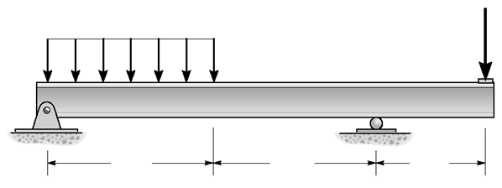
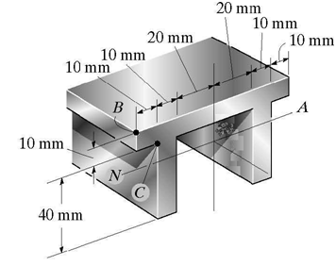
- For the simple supported beam shown in the figure
10 KN
3 KN/m
6 m
6 m
3 m
- Draw the shear diagram
- Draw the moment diagram
- Locate the centroid
- Find the moment of inertia about the horizontal neutral axis
- Determine the maximum flexure and shear stresses
- Determine the flexure and shear stresses point C.

